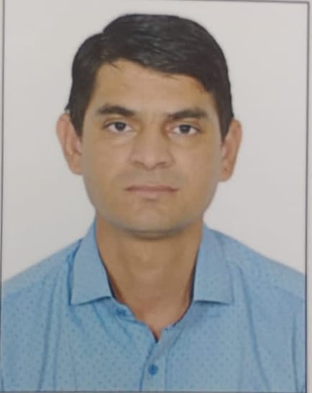 | jugraj  - jani  registered gnm staff
CONTACT  Rampura, Dabla  Dist- Ajmer  Jugrajjani7@gmail.com  Mobile no. 8866696356  Personal Detail  Date of Birth : 06/12/1990  Gender : Male  Nationality : Indian  Known Languages : Hindi, English, Gujrati, Rajasthani  OBJECTIVE  Enthusiastic & Dedicated nursing staff with strong commitment to delivering compassionate and quality patient care. Trained in evidence-based medicine to  support patients in recovery. Proven to quickly build trust and rapport with patients  of all ages. Rapid learning ability and commitment to patient health outcomes | Education  GNM - Bhopal nursing counselling  OT Technician – Punjab Paramedical counselling  Relevant coursework: Anatomy and physiology, pharmacology, nursing ethics, and patient care management.  Experience  12 years of Experience at Parimal Multi-speciality Hopsital, Ahmedabad  Working as OT assistant in Ortho, Gynec, Uro, Onco & Endoscopic Surgeries.  Experience of Autoclave surgical instrument.  Pre & Post operative Patients management.  SKILLS & ABILITIES  - Decision-Making capacity  - Health promotion awareness  - Humanitarian instinct  - Health advocacy  - Emergency medicine practices  - Communication skill  - Resilience under pressure  - Medical counselling proficiency  SELF DECLARATION  I hereby declare that information given above is correct & true.

