Email:drsdrawat03@gmail.com
Mobile no:+91-9887067079
Professional Details

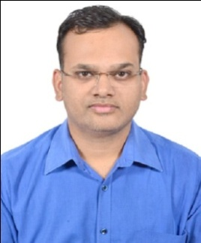

Personal Profile

Name : Dr.Sandeep Rawat
Date of Birth : 03-July-1984
Permanent Address : 47 Gangotri Nagar, Near Gopalpura Bypass
Jaipur. 302018 (Rajasthan)

Career Objective

Seeking for opportunity to work as consultant in cardiology department and to pursue my career where I could add my medical knowledge and good patient serving skills to hospital industry.

Academic Qualification

Qualification | Institution | University | Year of Passing
D.M.(Cardiology) | J.L.N.Medical College,Ajmer | Rajasthan University of Health Sciences | 2025
M.D. | Dr. S.N. Medical College, Jodhpur | Rajasthan University of Health Sciences | 2013
M.B.B.S. | Guwahati Medical College (Assam) | Gauhati University, Assam | 2008

Work experience:

- 2500+ angiography and 300+ angioplasties done independently including complicated and multivessel PCI.
- Trained in OCT,FFR,IVUS and ROTA guided angioplasty.
- Trained in BMV, ASD closure device and Pacemaker insertion.

- As DM Resident Cardiology at J.L.N. Medical College, Ajmer(From APRIL 2022 till date)
- Medical officer at CHC Railmagra,Rajsamand (From Dec.2022 to March 2022)
- Bhagwan Mahavir Hospital, Sumerpur, Pali (From Dec. 2014 to March 2019) as Consultant.
- Narayana Hridyalaya Hospital, Jaipur (From May 2014 to Dec. 2014) as Clinical Assistant.
- Fortis Escorts Hospital, Jaipur (From Jan. 2014 to April 2014) as Senior Resident.
- Metro MAS Hospital, Mansarovar, Jaipur (From Aug. 2013 to Dec. 2013) as Senior Resident.

Clinical research

- At RAJCSICON 2024,Paper Title : Clinical outcomes of PCI with full metal jacket Drug eluting stents (60mm) in patients with diffuse Coronary artery lesions
- At RAJCSICON 2024, E-poster Title : Congenital coronary cameral fistula from LAD to RV

Other trainings and Courses

- Basic Course in Biomedical and Research
- Good clinical and laboratory practice
- BLS and ACLS course

Key Skills
- Excellent theoretical and practical knowledge
- Excellent communication skills
- Good knowledge of clinical practices and protocols
- Ability to handle different types of patients in critical situations
- Flexible and adaptable
- Extremely motivated towards career
- Quick learner

Declaration
I here by declare that the above written particulars are true to the best of my knowledge

Yours Sincerely
Dr. Sandeep Rawat
Mobile No. 9887067079

