CURRICULUM VITAE
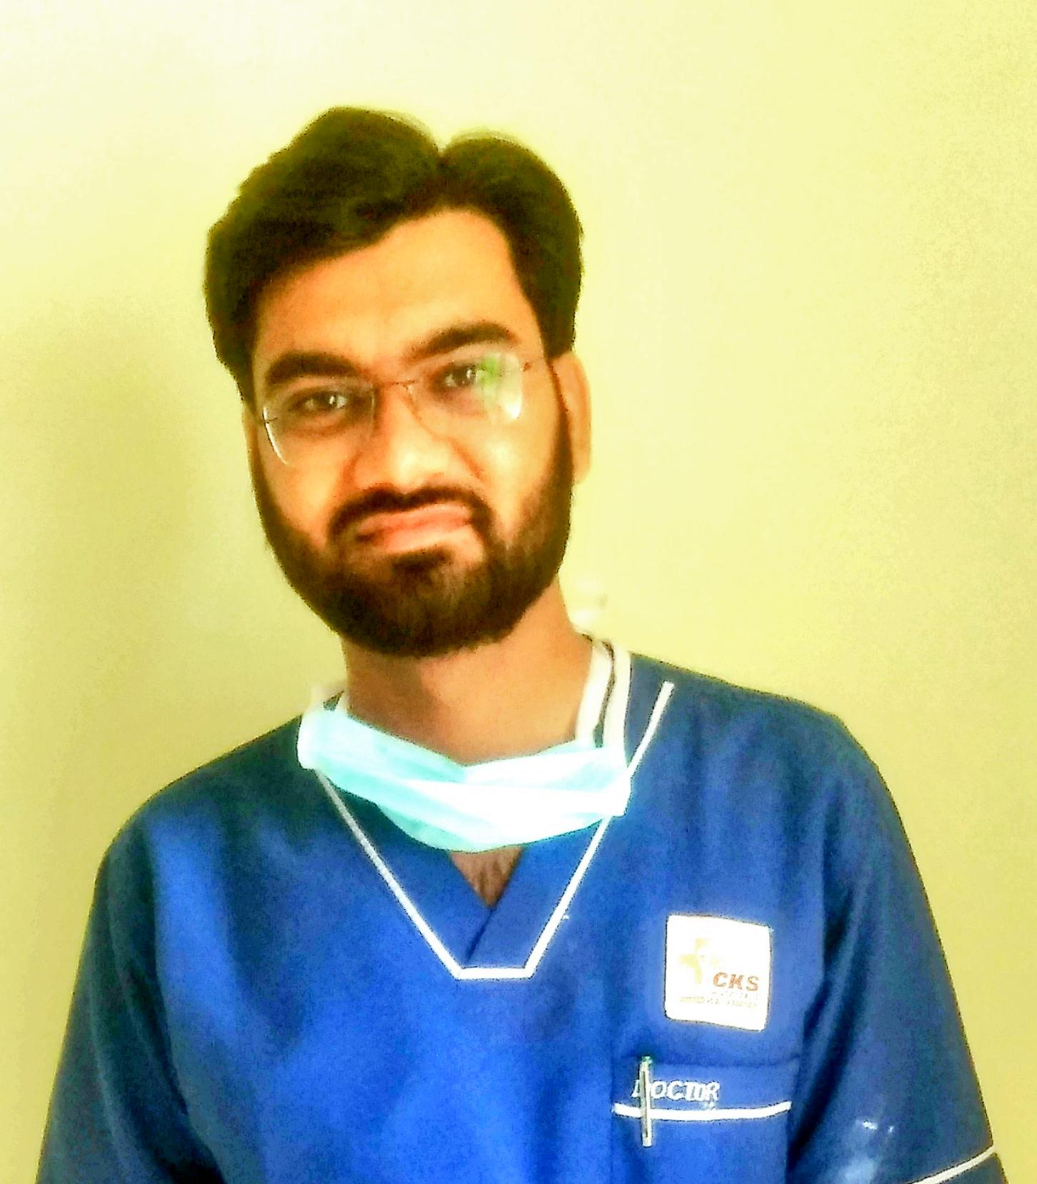
ROHIT MISHRA
E-mail : physiorohitmishra@gmail.com
Mobile : +91 9509006362
CAREER OBJECTIVES:

My career options have been guided by opportunities for self-expression, learning and prospects that offered me a diverse and challenging work profile. I believe in setting targets for myself and doing my utmost to achieve them. This has been aided by my sincerity, ability to stay put under uncertainty and pressure and a desire to excel.
EDUCATION QUALIFICATION:

- Secondary from Board of Secondary Education Ajmer. (2012)
- Senior Secondary from Board of Secondary Education Ajmer. (2014)
- Bachelor of Physiotherapy from Jaipur Physiotherapy College, jaipur.(2019)
- Certified Course in Community Health and CMS ED from MANSA INSTITUTE, Jaipur.(2023)
- MBA in Hospital and Health Care Management.(Distance) from JECRC University, Jaipur.(2023)
Extra Qualifications:

- Certification in Dry Needling.
- Basic Knowledge in Computer Application.

Work Experience

- Worked as Orthopedic Resident & Coordinator in Dr. Vishnoi’s bone joint and spine Hospital, Jaipur & Phulera.( 2022-2023)
- Worked as a Orthopedic Resident in CKS Hospitals, Jaipur.
- Worked as a Orthopedic Intern & Coordinator in Advance Orthopedic Hospital, Jaipur.
- Worked as a physiotherapist in CKS Hospitals (a Unit of Lavanya Health Care).
- 6 months Worked Experience as Internship from CKS Hospitals Jaipur.

Date of Birth : 18TH May 1997
Sex. : Male
Father's Name : Sh. Prabhu Dayal Mishra
Marital status : Unmarried

Address : A-56, sumel vatika, sumel road, agra road, jaipur, 303012

Languages Known : Hindi, English

Hobbies
- Playing Cricket
- Music

- STRONG POINTS : Discipline, Team Work, Self confident, & Motivated, Always Think New and Serve
Affirmations

I solemnly declare that the statements made by me in this form are correct to the best of my knowledge and belief.

Place:
Date:
(ROHIT MISHRA)

