CURRICULUM VITAE
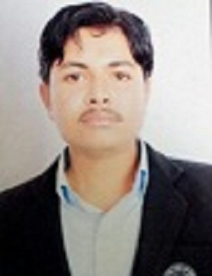
LOKESH SINGH RATHORE
Add. V/p – Lokesh Singh Rathore
S/O Shankar Singh Rathore
Vpo Bherunda
Teh. - Riyanbadi
District – Nagaur (Raj.)
Pin No. 341031
Mobile No. 7976972332
E-mail :- lokeshrathore551.lr75@gmail.com
CAREER OBJECTIVE
To excel in my profession by increasing the sphere of my knowledge, improving the quality of work through experience and dedication and contributing towards the development of organization and achievement of organizational goals.
ACADEMIC QUALIFICATION
CLASS | BOARD | SCHOOL/ Institute | YEARS | TOTLA MARKS | PERCENTAGE
10 | BSER | Sharda SEC. SCH BHERUNDA NAGAUR | 2011 | 342 | 57.00
12 | BSER | Rajtagor SR. SEC. SCH Thanwala NAGAUR | 2013 | 277 | 55.40
GNM | RNC | RNC Jaipur | 2021 | 1256 70
Registration number RN 164193 RM 155101
STRENGTH
Hard working, Confident & Punctuality
PERSONAL INFORMATION
Date of Birth :- 10st Oct., 1997
Father’s Name :- Mr. Shankar Singh Rathore
Mother’s Name :- Mrs. Sonu Kanwar
Status :- Unmarried
Nationality :- Indian
Religion :- Hindu
Language Known :- Hindi&English
Hobbies :- Reading News Paper, Watching Cricket &
Listening to Music
DECLARATION
If given as opportunity to serve l assure than my performance could be whole hearted dedicate and always to best capacity and the prestige.
Date: With Regards

Place: (Lokesh Singh)

